Distributed Vision-Based Target Tracking Control Using Mobile Robots

Anthony Le and Ryan Clue

Advisors: Dr. Jing Wang, Dr. In Soo Ahn

Abstract

This paper describes a Bradley University Electrical Engineering senior capstone project for a distributed vision-based control system designed for multiple mobile robots to explore the problem of target tracking while maintaining a specified formation among tracking robots. The paper describes related research and the problem formulation for the Kinematic Model of mobile robots utilizing vision-based control for this project. The design of the project’s distributed vision-based control system can be divided into two specific modules: 1) Identifying target and spatial information using images and 2) coordinating motion of multiple robots using autonomous encirclement and formation controls. The project design approach described includes: system/subsystem function definition, QBot2 Mobile Robot hardware and software description, target identification image processing and QBot2 control (vision-based control, encirclement, leader-follower) description. The system integration and testing tasks, experiments and results are also described in the paper as well as project management (resources, task plan and timeline) and the overall design experience from our engineering research project.

# Table of Contents

1. Introduction  
                1.1 Motivation for Research Project  
                1.2 Related work  
2. Problem Formulation  
                2.1 Kinematic Model of Mobile Robots  
                2.2 Basics of Vision-based control  
                2.3 Project objectives  
3. Design of Distributed Vision-Based Control  
                3.1 Design approach  
                3.2 QBot2 Mobile Robot

3.2.1 Hardware

3.2.2 Software

                3.3 Target Identification

3.3.1 Interface and Inputs to Target Control

3.3.2 Acquire Y Component of Target Location from Color Image

3.3.3 Acquire X Component of Target Location from Depth Image

                3.4 Control

3.4.1 Encirclement

3.4.2 Leader-follower

4. System Integration and Testing  
                4.1 Implementation  
                4.2 Tasks Coordination (Stateflow mechanism)  
                4.3 Experiments  
                4.4 Results  
5. Project Management  
                5.1 Division of labor  
                5.2 Gantt Chart and Timeline  
                5.3 Discussion  
6. Design Experience  
                6.1 Improvement of the design  
                6.2 Impact of design  
                6.3 Economic analysis  
                6.4 Learning experience  
7. Conclusion  
                7.1 Discussion  
                7.2 Future work  
  
        References  
  
        Appendices

## Introduction

## Motivation

Distributed control of multiple unmanned autonomous robots (UARs) has been the subject of intensive research in recent years due to the potential applications in search and rescue missions, surveillance and reconnaissance, environmental sensing and monitoring, intelligent transportation and threat isolation/evasion, and obstacle evasion [1]. There are many practical commercial, civil and military applications that may benefit from advancements in UAR control strategies and algorithms from this area of research.

## Related work

Methods for successfully coordinating multiple robots to autonomously encircle a target point have been put forth by several research papers. These distributed controls assume communication the robots to communicate their kinematic state variables between one another, and consequently researchers have designed their algorithms in ways that minimize the number of communication channels required between robots. However, there has not been nearly as much research done that attempt to implement coordinated encirclement that rely entirely on each individual robot’s vision sensors.

A review of prior work at Bradley and research literature was conducted by our team during the conception phase of the project. This included a review of e prior Class of 2016 Senior Project, Cooperative Control of Heterogeneous Mobile Robots Network [cite ref 1?]. The 2016 research and capstone project experience using the QBot2 robots was leveraged in our project. The 2016 project tested cooperative control using the QBot2 platform including the Qbot2 Camera and the Kinect RGBD camera for localization. Wiﬁ communication was used to exchange position information among robots. Consensus and formation stabilization problems were studied.

Our project also researched and references another work, highly relevant to our 2017 project objectives. Decentralized multi-robot encirclement of a 3D target with guaranteed collision avoidance for object tracking and encirclement by Franchi, Stegagno, and Oriolo, [cite ref 2]. Their work on 3-D (and 2-D) and distributed collaborative control is extensive and leverages research going back to 2001. Their findings delivers a control framework for achieving encirclement of a target moving in a 3D space using multiple robots, image-only sensing, and requiring local communication between exactly two other members of the encircling group of robots.

An additional consideration, for a vision-only sensing strategy was image processing techniques and algorithms. We relied on Peter Corke’s book “Robotics, Vision and Control” as well as his Matlab toolbox for much of our image processing. The academic tutorials packaged with the Qbot2 were also valuable resources. It is worth mentioning that systems in the literature utilizing visual-only sensing generally assumed 360-degree robot sensing (e.g. fisheye camera). Ref 1 Research (extracts below) utilized a 240deg field of view sensor and a laser range finder for identification and locating targets to support inputs to their control strategies. Because the Qbot2 cameras have less than a 90-degree field-of-view, our design would have to incorporate additional logic to locate targets outside the robot’s visual range.

## Problem Formulation

## Kinematic Model of Mobile Robots

Depending on whether the robot is following a target or leader robots, two separate control modules are used. Both modules use a Cartesian coordinate system and follow a target point, which is obtained by transforming the current or previous result of the image processing module with respect to the robot’s current position.

## Vision-based control

The purpose of the vision-based control is to provide a target point to the kinematic control, which it accomplishes by processing the Qbot2’s color images and depth images. This control should also provide additional information as to whether the target point it provides should be considered valid or not.

## Project Objectives, Goals, and Approach

The goal of our project is to design distributed vision-based control algorithms for mobile robots and to implement and validate the proposed algorithms. The primary project tasks (research, concept definition, design, and demonstration) tasks included:

1. Design a target identification (detect and locate) module based on RGB image features obtained from a vision sensor
2. Design a target tracking algorithm based on robot model linearization
3. Design a leader-follower formation control algorithm based on depth and image features provided from the target identification module
4. Design a state machine to coordinate target identification module and target control module and communications between Robots
5. Integrate and validate the proposed distributed controls through experimentation in a controlled lab environment

## Project Assumptions

The Lab environment, limitations of the research and practical limitations (and availability) of fully operational equipment are also considered.

* The lab environment will be a well-lit, indoor area
* The target will remain on the same level plane as the robots (2D motion tracking).
* The target will not move faster than the Qbot2s maximum velocity (0.7 m/s).
* The target will be a solid colored, basketball-sized sphere.
* The environment will be reasonably free of similarly colored objects.
* As stated above the multiple robots must use same control strategy.

# Design of Distributed Vision-based Control

## Design approach

The basic “system” is comprised of the QBot2 Mobile Robot and QUARK Control Software on a host computer. The full “system” is comprised of multiple QBot2s collaboratively tracking a single target with the Quark Control Software Computer. Note: An assumption is that the Quark Control Software on the host computer could be ported entirely to the robots, given sufficient processing and communications, to attain higher autonomy and actual decentralization of the system. The target in the experiment is a round ball that is detected, located, and tracked by the multiple QBot2s.

Subsystems for the basic system, a single QBot2, include: the Qbot2 mechanical/motors/control subsystem, the sensing/image processing subsystem, and the communications/processing subsystems (on the Qbot2 and the Host computer).

## QBot2 Mobile Robot and QUARK Platform

The QBot2 utilizes QUARC’s HIL software suite to allow users to design their program using Matlab and Simulink. The Simulink model and Matlab code are translated to C++ code by the QUARC software and compiled automatically on the Qbot2’s computer.

3.2.1 Hardware

The QBot2 comes equipped with a differential drive robot base which has a maximum speed of 0.7m/s. A v1 Kinect-for-Xbox mounted on the robot base provides both color and distance vision information. The RGB image that has a default resolution of 640 × 480 pixels and a 57° × 43° field of view. The depth image has a resolution of 640 × 480 pixels, approximately 52.5° × 41° field of view, and measures distances from 0.5m to 6.0m. It is worth noting that the accuracy of the depth map depends on the detail of the grid projected by the IR emitter, the actual accuracy of the depth image is significantly lower than a resolution of 640x480 implies. QBots use IEEE 802.11 b/g/n protocol for communication between the computer and QBot2. TCP/IP protocol is utilized, with each QBot2 using a statically assigned IP address. More information on sensors can be found in the appendix.

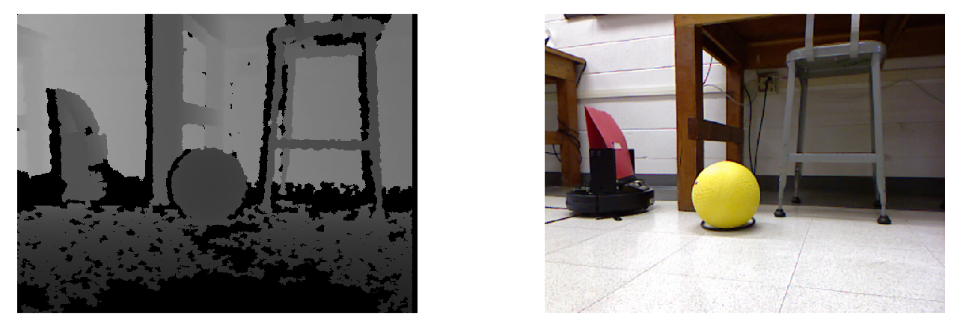

Fig x: Side-by-side of color and depth images

Figure 3-1: QBot2 Mobile Robot

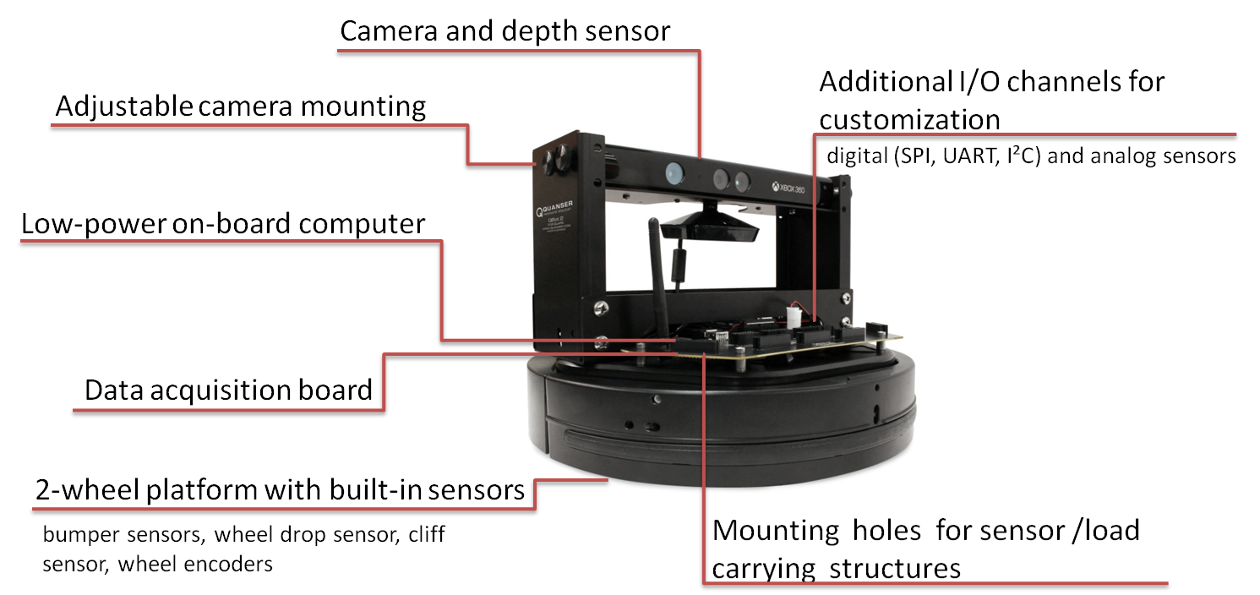

3.2.2 Software

To connect to the QBOT2 A host-target real-time control system [2] is utilized. As shown in Figure 3-2, the target QBOT2 computer is connected wirelessly with the host computer on which the SIMULINK model is running. The control algorithms are developed in MATLAB/SIMULINK with QUARC on the host computer. The control models are cross-compiled and downloaded to the target computer in real time.

Figure 3-2 Host Computer / Wi-Fi Router to Qbot Communications Connectivity

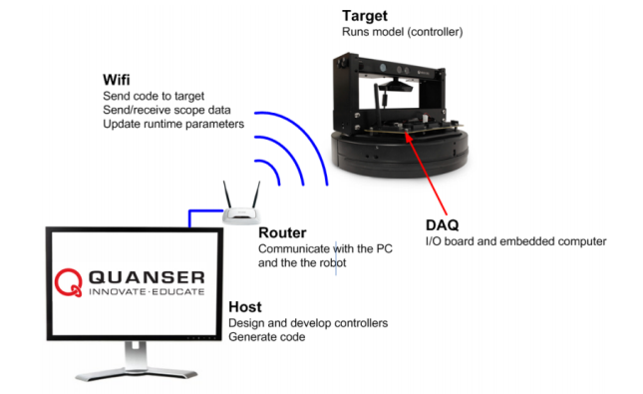

## Target Identification

## Interface and inputs to Target Control

The result of the vision control system is a target location given in 2D Cartesian coordinates. The origin of this coordinate plane is at the Qbot2’s camera position, the positive X axis extends in same the direction the Kinect is facing and the positive Y axis extends to the left (or “port” side) of the Kinect. The motion control module will then transform this point according to its current kinematic state. This is target point is the basic interface between the target identification module and the motion control.

Based on the 2016 Senior Project, and research of alternatives, we chose to use the color image for object/target recognition and the depth image for determining distance to the target. Our choice was driven primarily by practical QBot2 processing limitations and timing restrictions prohibiting potentially more robust methods of object detection (see Appendix).

## Acquire Y Component of Target Location from Color Image

We perform all object recognition on the color image. Consequently, color image processing is the primary bottleneck in system performance. We initially selected color thresholding with blob detection because it is the easiest image processing method to implement. Although we did pursue alternative methods of image processing, these implementations were unable to meet our performance requirements due to limitations of the Qbot2 hardware. Therefore, color thresholding with blob detection was selected because it had a significantly lower performance requirement while also producing adequate results.

The first stage of image processing, color thresholding, highlights all elements of the image that correspond to our target’s color. During this stage, pixels with RGB values that fall within a pre-determined range are replaced by ‘1’ in the binary output image, while all other values are replaced by ‘0’.

Blob detection is applied to the binary output image from color thresholding. The goal is to identify the largest grouping of neighboring, non-zero values. Then, for each group (or “blob”) of neighboring pixels, we calculate its centroid by finding the mean index of all pixels contained in that blob. This means that the accuracy of the blob corresponding to our target object is unaffected by “noise” from similar colors appearing elsewhere in the image. It should be noted that the accuracy of this method is therefore entirely dependent on the color thresholding result.

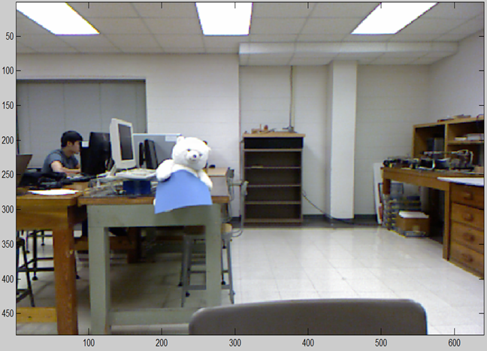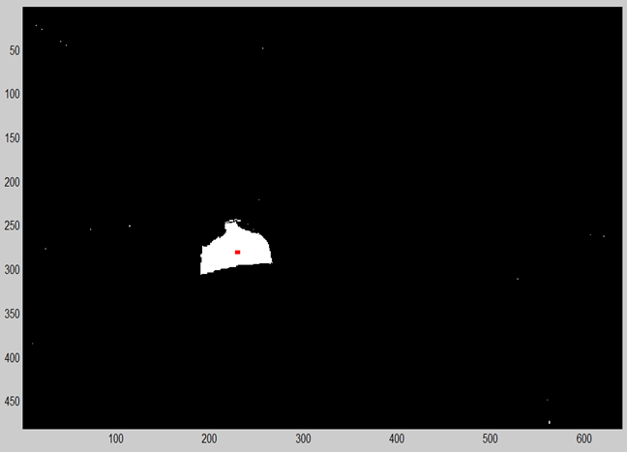

Fig x: Color thresholding and blob detection example

The blob detection outputs a list of centroids and corresponding blob sizes. If the blob size of the largest blob is greater than some pre-determined threshold value, our system will use that centroid for the target’s coordinates on the RGB image plane.

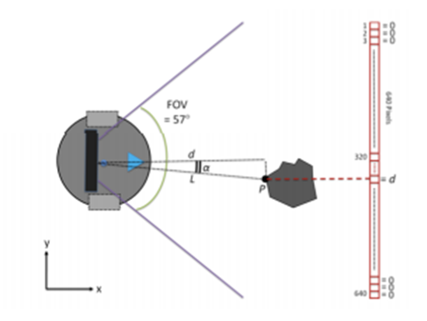

3.3.3 Acquire X Component of Target Location from Depth Image

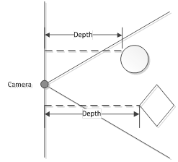The target’s location on the depth map can be estimated by translating points from the color image plane to the depth image plane. We calculated this using the ratio between the two images’ field-of-view and the estimated angle from the RGB image.

Fig x: Depth values

## Control

## Encirclement

The target control module relies on received target coordinates from the image processing module and the robot’s x,y, and theta. These are inputs which allow for formulation of encirclement. From the robot’s x,y, and theta values, we transform these values to the appropriate kinematic model for the QBot2. From this kinematic model, we transform the cartesian local coordinate system to a cylindrical coordinate system. The length between the two wheels of the QBot is 0.0235 meters. To find the forward point location of the robot, we use,

|  |  |  |
| --- | --- | --- |
|  |  | (1) |
|  |  | (2) |

Following, we want to define qi,

|  |  |  |
| --- | --- | --- |
|  |  | (3) |

and convert these values by,

|  |  |  |  |
| --- | --- | --- | --- |
|  | |  | | --- | |  | | (4) |
|  |  | (5) |

where p is the pose of the model.

and are the forward velocity and angular velocity computed by:

----

|  |  |  |
| --- | --- | --- |
|  |  | (6) |

|  |  |  |
| --- | --- | --- |
|  |  | (7) |

where kr is the porportional gain and is the size of the encirclement radius. is the approximate distance from the robot to the target given from the inverse kinematics and image processing modules.

We then use the Jacobian matrix of the difference between the target and robot where Px and Py is the X and Y coordinates of the robot and Pxt and Pyt is the X and Y coordinates of the target in relation to the robot’s coordinate frame. The difference of the robots X and Y locations can be reduced to Pxd and Pyd. and the following Jacobian matrix can be computed

|  |  |  |
| --- | --- | --- |
|  |  | (8) |

From the Jacobian, the following input velocities Ux and Uy can be computed

|  |  |  |
| --- | --- | --- |
|  |  | (9) |

For the velocity inputs, Ux and Uy , they are transformed using the inverse kinematic equations

|  |  |  |
| --- | --- | --- |
|  |  | (10) |

to find Vc and

|  |  |  |
| --- | --- | --- |
|  |  | (11) |

Once Vc and Wc are found, using

|  |  |  |
| --- | --- | --- |
|  |  | (12) |
|  |  | (13) |

we can find velocities of the right and left wheels, Vr and VL.

Right and left wheel velocities are then sent to the HIL Write block which sends data to the 2000 and 2001 ports of the QBot2 for the left and right wheels, respectively.

The QBot2 stores wheel encoder data to allow calculation of actual right and left wheel velocities. This data is taken from the HIL Read block. For each wheel encoder ticks, we can determine the velocity of each wheel. The robot’s x,y, and values are then updated and sent back into the control module using Vc and where,

|  |  |  |
| --- | --- | --- |
|  |  | (14) |
|  |  | (15) |

From Vc and , we can determine the robot’s X, Y, and values by calculating the integrals for

|  |  |  |
| --- | --- | --- |
|  |  | (12) |
|  |  | (13) |

|  |  |  |
| --- | --- | --- |
|  |  | (14) |

## Leader-follower

Leader-follower control module does not take into account inverse kinematics and only use target’s x and y locations. Given the radial distance of the target, Vw and are calculated. A follow distance of 0.5 meters and gains Kw = 0.5and Kv = 0.2 were defined as per limitations for the QBot.

To determine Vc and ,

|  |  |  |
| --- | --- | --- |
|  |  | (15) |

|  |  |  |
| --- | --- | --- |
|  |  | (16) |

where xt and yt are the positions of the target in relation to the robot’s local coordinate frame.

One should note the limits for angular and forward velocity are set to .2 m/s.

# System Integration and Testing

## Implementation

The Simulink model is configured using the HIL block from the QUARC toolbox. This enables users to more easily run their simulations in a virtual environment as well as on actual hardware. The project must also be configured to communicate with a specific IP address, which can be done through the QUARC add-on options menu in Simulink. It is also important to set the sample time configure the “Solver” pane of the Simulink model configuration. It is important to select the “ode1” and “fixed-step” options. Additionally, when performing operations on images or large arrays of data, it is recommended that users select a sample frequency no greater than 15Hz. Our experiments used a 10Hz sample frequency.

## Tasks Coordination

Our system would need to switch between two modes of operation depending on whether or not the target was in view. Stateflow was used to control the varying states in our model. Models for both target encirclement and leader-follower used similar simulink and stateflow models with differences only in controls and how often a search was made. In both models, search mode is done by toggling between image processing and rotating. Once the desired accuracy is obtained from blob detection, the state switched to the control module. The target encirclement model only searches for target every set time-interaction whereas leader-follower will search for a target every other time-step.

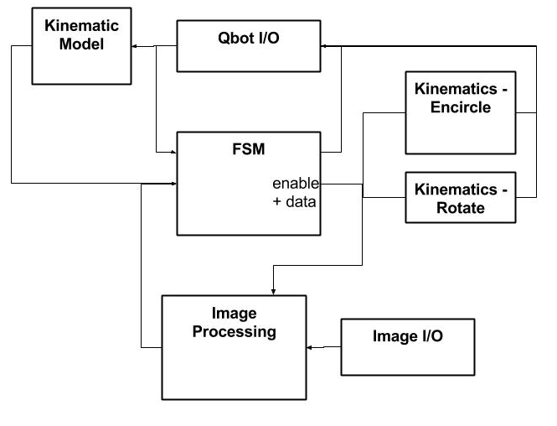

Fig x: Abstracted View of Simulink Diagram

* + 1. Target Encirclement FSM

In the stateflow for target encirclement control, various enable switches allow triggering of different modules. The system starts off with all enable switches off. While entering target acquisition mode, image processing module is enabled and determines if an image centroid can be made. If no centroid is found, the QBot2 will rotate 15 degrees on its axis and wait for the cameras to update. If a centroid can be made, it checks whether the pixel size of the image is greater than a certain value. In our case, a yellow ball or box is used. If 30 pixels are connected, the robot will continue into the encirclement module. Data from the image processing, such as the robot’s x, y, and theta, is also sent to the encirclement module. From this module, the target location is stored and encirclement is based on this value. After 120 seconds, the encirclement ceases and target acquisition mode begins again

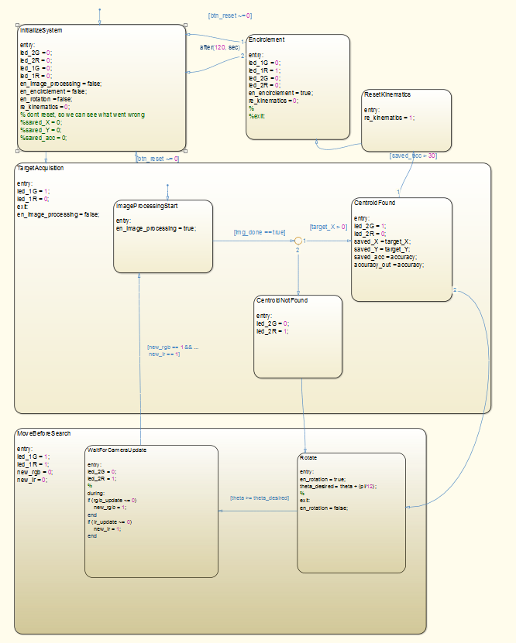

* + 1. Leader-Follower FSM

Leader-follower control is similar to target encirclement control. However, instead of returning to Target Acquisition mode, the target will continue to follow any centroid even if the pixel count is less than 30. The process is done by continually switching from image processing and the leader-follower control module. If no centroid is found, the target will return into Target Acquisition mode.

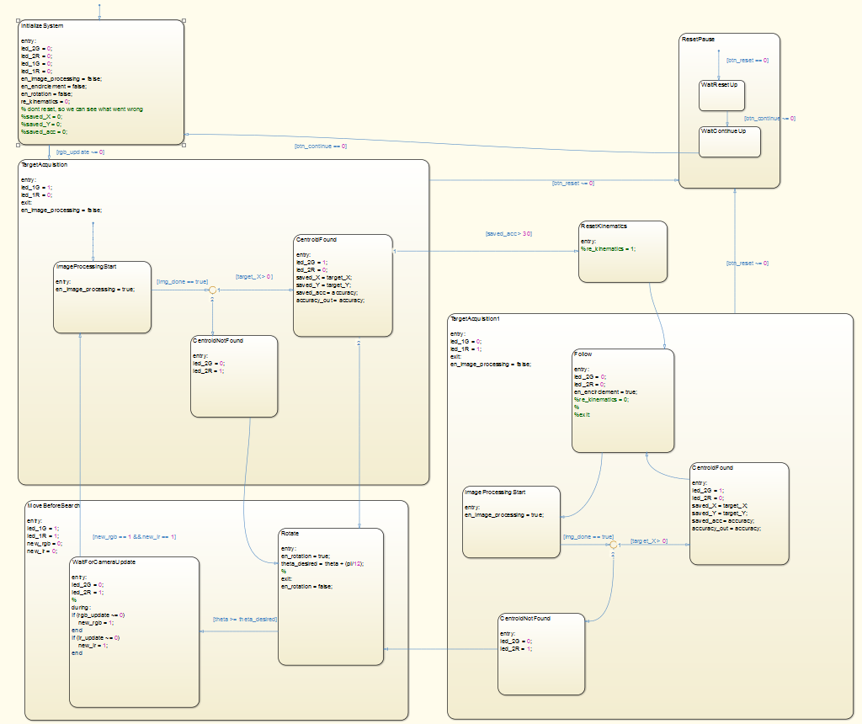

**keep these in main section, not appendix for now

** ADD: explain why we need stateflow, advantages of using stateflow

*** pay attention to capitalization (all use of Stateflow/Simulink needs capital S, not “stateflow”)

## Experiments

A curriculum for the QBot was provided to allow interfacing and familiarity of the QBot2 and its software package, QUARC. The curriculum covers topics ranging from QBot communication, integration, kinematics and vision guided control. Advanced topics such as path planning, mapping, and localization are also covered. Each section provides an in-depth tutorial for the understanding of the QBot’s capabilities. Tutorials for blob detection, line-following, and kinematics were most referenced in our project.

Various simulations for the control module were implemented in Matlab and Simulink. These demonstrations assumed constant communication between robots. For encirclement control, single robot to a multiple robot models were simulated to show proof of concept. Refer to the appendix for more information.

From simulation, the first series of experiments were conducted. Using a predefined target point, encirclement of a single robot was tested. Our next iteration, using blob detection, allowed us to capture and encircle the target point. The next iteration consisted of determining which method of control was needed to allow coordination between robots. Stateflow was used to control different modules efficiently. Following, a leader-follower model was implemented for successive robots.

## Results

Experimental results can be seen in figures below. Target encirclement was achieved by the target robot. Using the appropriate thresholds for the color yellow, the robot was able to identify the target.

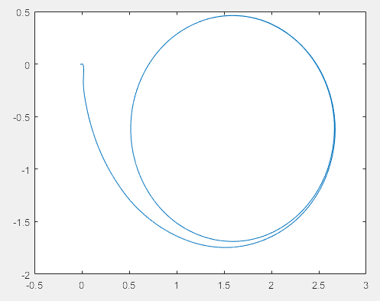

Figure : Encirclement of Leader Robot at approximate point (1.7,-.7)

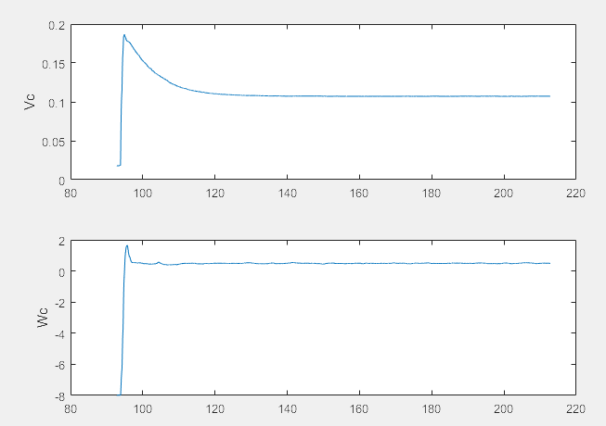

Figure: Vc & Wc of Leader Robot

In the figure below, the follower robot tracks the leader robot’s position. The leader stops at points (-1,-1.5) and enters Target Acquisition mode while the follower robot continues to track the leader.

*** add labels to units in all graphs (meters)

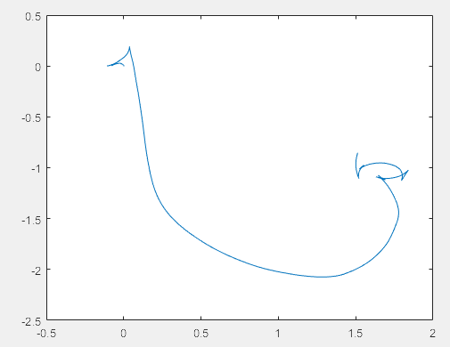

Figure: Follower following path of Leader Robot while leader robot entered search mode

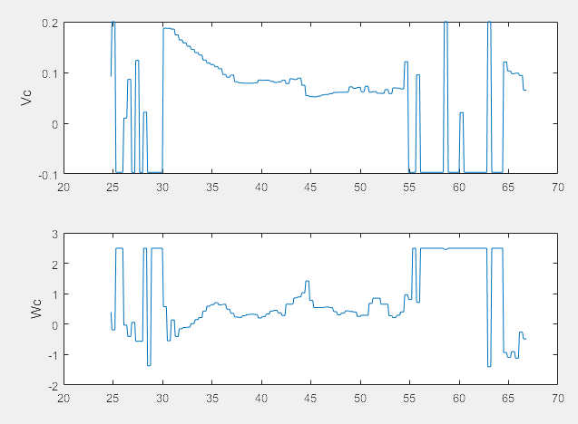

Figure: Vc and Wc of Follower Robot in Leader-Follower Experiment

*** verify the x axis is time or indices?

# Project Management

## Division of labor

Ryan Clue implemented our image processing methods, created the initial Stateflow model, and provided the Simulink design for integrating the image processing modules with the kinematic modules.

Anthony Le implemented our kinematic control systems, created our Matlab data logging module, and extended our Stateflow model for the Leader-Follower program.

Anthony and Ryan worked jointly to debug and troubleshoot.

## Gantt Chart

# Discussion of Design Process

## Impact of the Design

Our design allows limited communication and sensing among all robots. Assuming a leader and its peripheral robots, we can obtain encirclement with each consecutive robot containing a smaller and smaller encirclement radii. This two part modular design allows for classifying the leader and followers and allows for increased modularity and customization if needed. With Stateflow, replacing a certain image processing or control module is as simple as replacing or rewriting a Simulink block. Creating simulations for certain environments can also be implemented using Stateflow.

The overall design can be implemented in search and rescue missions, environmental surveying, and much more.

## Future Work

There are two areas that can be significantly improved or developed.

The first improvement would be to implement collision avoidance. This would involve additional image processing as well as control logic. The kinematic control can be improved to accommodate obstacle avoidance by scaling the encirclement radius as the Qbot2 approaches the obstacle in its path (ref encirclement paper). As for identifying the obstacle, we believe that this can be accomplished identifying expected distance from the floor and identifying all image elements that deviate from that expected floor distance.

The method of object recognition could also be improved. One possibility is using edge detection and performing a Hough Transform for the expected target object shape.

# Conclusion

## Conclusion (state achievements, failures)

Our project have demonstrated distributed vision-based target tracking control using mobile robots. We have achieved the project goals mentioned in Section 2.3 – that is to design a target identification (detect and locate) module based on RGB image features obtained from a vision sensor, to design a target tracking algorithm based on robot model linearization, to design a leader-follower formation control algorithm based on depth and image features provided from the target identification module, to design a state machine to coordinate target identification module and target control module and communications between robots, and to integrate and validate the proposed distributed controls through experimentation in a controlled lab environment.

All the while, there were still problems with the upcoming design. The QBot2 does not contain enough processing power for the image processing that we desired – therefore, blob detection was used. A better target recognition algorithm, such as hough transforms, allows a more robust target detection method. Failures, such as the target being misclassified or kinematic issues, were also noted and fixed during implementation. The Qbot occasionally would reset and move backwards once a target object was found. We believe this may be an issue with misclassification or a faulty kinematic model. Another problem with the QBot concerned the updating of RGB and IR images. The middleware for the Simulink design block that increased a tick for every image update occasionally would not change. This prevented us from keeping track each time image processing was finished and delayed search mode.

Overall, this project demonstrated that minimized local communication and formation between robots is feasible. Future work, such as obstacle avoidance and improved image processing, can still be researched.

8.0 References

Todo (don’t forget to number references for in-text citations)

9.0 Appendix

Todo

References

Ref 1: Last Name, F. M. (Year). Article Title. *Journal Title*, Pages From - To.

Ref 2: Last Name, F. M. (Year). *Book Title.* City Name: Publisher Name.

Ref 3: Last Name, F. M. (Year). *Book Title.* City Name: Publisher Name

Other Research Paper References helpful in gaining knowledge of state-of-the-art and terminology:

Cognetti, M., Stegagno, P., Franchi, A., Oriolo, G, Bulthoff, H.  **IEEE** ***Xplore*:** 28 June 2012, Robotics and Automation (ICRA), 2012 IEEE International Conference, IEEE *Xplore*: 28 June 2012, IEEE.

Franchi, A., Stegagno, P. & Oriolo, G. Auton Robot (2016) 40: 245. doi:10.1007/s10514-015-9450-3. Decentralized multi-robot encirclement of a 3D target with guaranteed collision avoidance

Refx DAS, A.K., Fierro, R., Kumar, V.: IEEE 2002, Volume: 18, Pages 813 - 825 [Issue: 5](http://ieeexplore.ieee.org/xpl/tocresult.jsp?isnumber=22928), Oct 2002, IEEE. A vision-based formation control framework

Refy Moshtagh, N., Jadbabaie, A., Daniilidis, K., IEEE *Xplore*: 26 June 2006, Pages 15-19, IEEE. Vision-based control laws for distributed flocking of nonholonomic agents

Refz Mariottini, G.L., Morbidi, F., Prattichizzo, D., Pappas, G.J., Daniilidis, K., IEEE *Xplore*: 21 May 2007, Pages , IEEE,

Leader-follower formations calibrated vision-based localization and control

Footnotes

1